
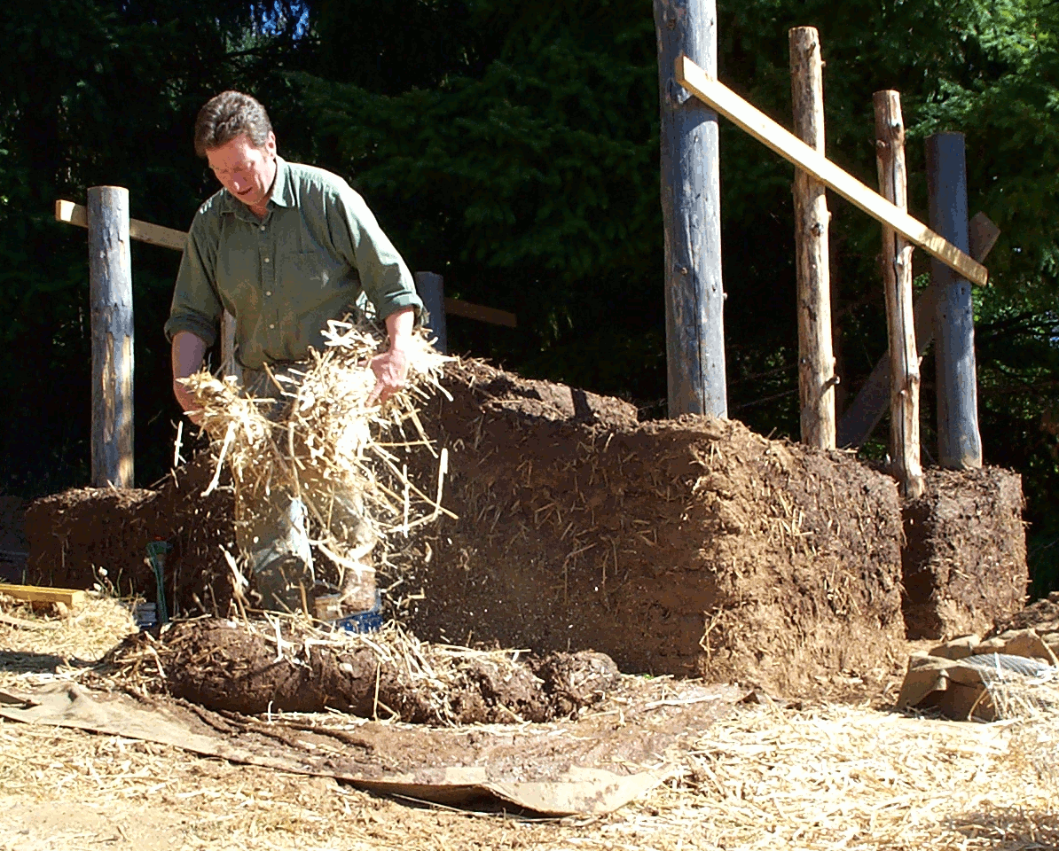
Re-”building” Your Life

How to outsmart the recession, live a better, happier life and improve the planet in the process.

You are invited to attend a presentation by Shannon Dealy, natural building instructor, software engineer / computer consultant and environmental activist who promotes truly sustainable living. Topics covered will include: natural housing, personal finance, lifestyle, resource consumption and creating a better life. Be prepared to look at your life and the world in ways you never considered!

While traveling and teaching overseas Shannon has been interviewed on radio and television in Australia and New Zealand. Creator and administrator of the internet discussion group on cob (an old English building technique), webmaster for Cob Cottage Company, and former “Eco-Yuppie”, Shannon has been researching and experimenting with lifestyle, houses, technology and much more for over 30 years.

Comments by past audience members:
“You should be on national television!”
“But you look so normal.”

Date:
Time:
Venue:

